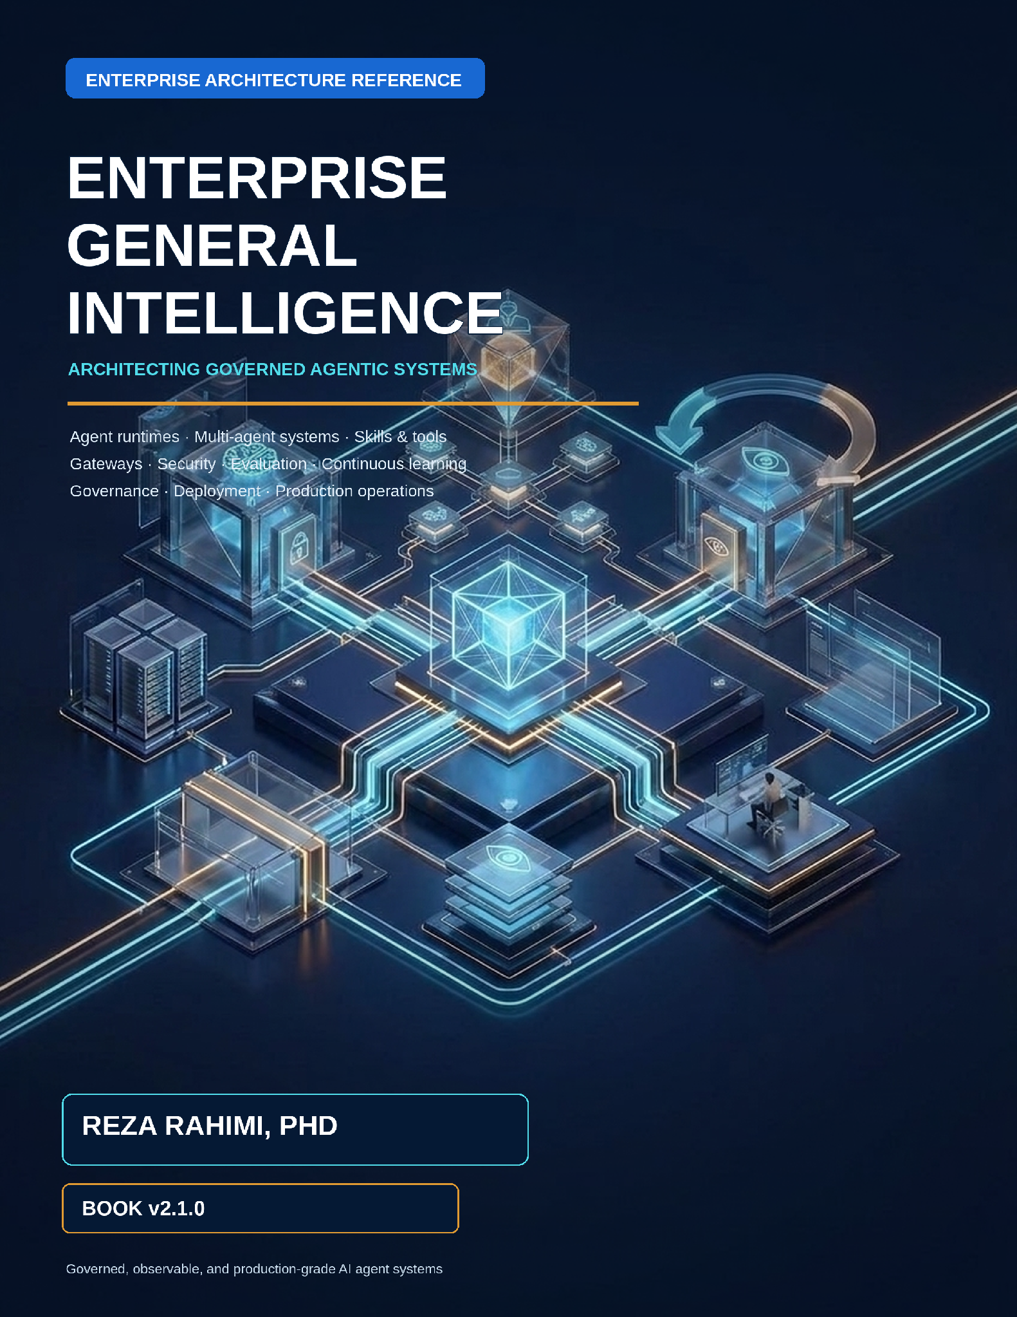

Enterprise General Intelligence: Architecting Governed Agentic Systems for the Enterprise
Book v2.1.0 · Publication Release · September 2026
Reza Rahimi, PhD
A structured enterprise reference for executives, architects, platform teams, security leaders, SREs, and senior engineers.

Preface to Book v2.1.0
Book v2.1.0 is the publication baseline for this guide and the canonical starting point for all future editions. It treats an agentic application as a governed distributed system: models may propose, while deterministic services own authority, state, effects, evidence, acceptance, and release.
The narrative follows one dependency chain. Foundations establish the deterministic shell; the reference architecture assigns ownership; the developer platform makes those controls reusable; patterns and anti-patterns guide topology; gateways and security enforce boundaries; observability and evaluation produce evidence; continuous learning converts evidence into governed change; and production operations keep the resulting system reliable and economical.

Scope and claim discipline
External facts, protocol behavior, framework capabilities, research findings, standards, and legal or regulatory context use numbered citations such as [R05]. Architecture choices without citations are recommendations authored for this book; they must be validated against the reader’s workload, jurisdiction, threat model, provider terms, and operating constraints. A source supports only the claim stated beside it—vendor documentation does not establish production fitness, community guidance is not law, and a benchmark result does not guarantee enterprise outcomes.

Reproducible edition
The accompanying Book v2.1.0 development package contains this canonical Markdown, the generated DOCX, source files, cover and diagrams, a reference registry, style tokens, templates, skills, build tools, validation tools, and release evidence. Future agents should modify the canonical Markdown and registries, never hand-format the release DOCX. The build and validation workflow is documented in the package README.

How to use this guide
This guide is organized as one architecture story rather than a collection of independent topics. Read the executive map, then follow the lane that matches the decision. Every major chapter moves from problem and boundaries to architecture, implementation, failure modes, metrics, trade-offs, and review questions.
Reader | Primary path | Decision supported
Executive and product leader | Parts II, III, VIII and Appendix G | Investment, operating model, risk appetite, platform scope, and outcome governance
Enterprise / solution architect | Parts I–VIII | Boundaries, contracts, topology, integration, security, and lifecycle
Platform engineer | Parts II, III, V–VIII | Reusable control planes, SDKs, gateways, telemetry, release, and operations
Application developer | Parts I, II, III, IV, VII | Agent design, knowledge, tools, Skills, tests, debugging, and improvement
Security / risk / privacy | Parts II, VI, VIII and Appendices F, K | Knowledge governance, threat controls, evidence, approvals, exceptions, and assurance
SRE / operations | Parts VII, VIII and Appendices B, L | SLOs, incidents, recovery, capacity, and verified-success economics

Architecture at a glance
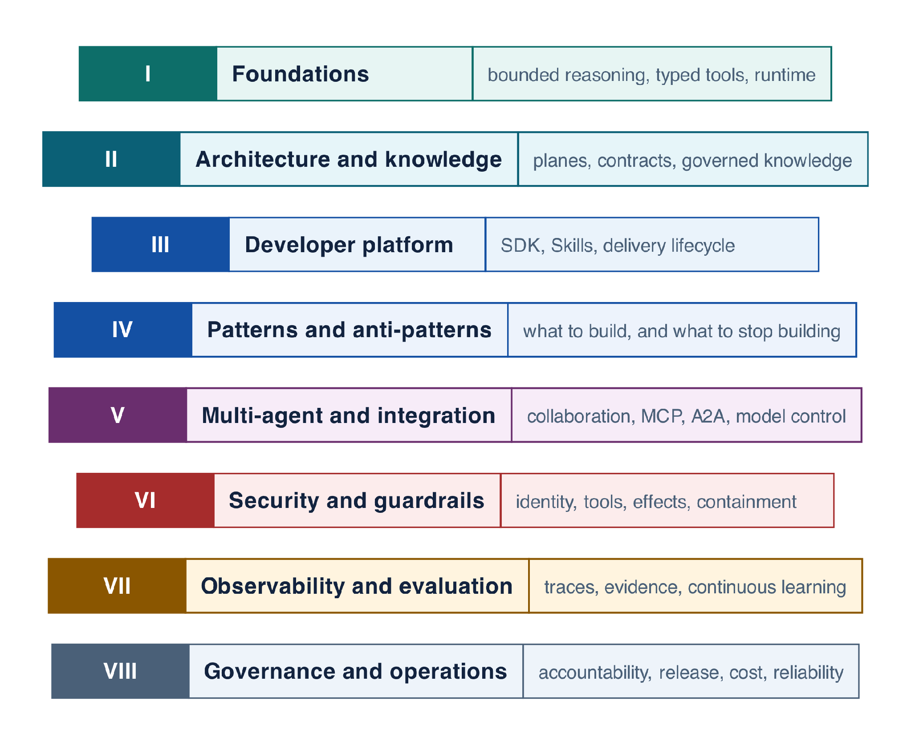
Figure 0-1 — Narrative map from foundations to production operations

Reference-guide contract
- Probabilistic components propose; deterministic components authorize and commit.
- Every run is pinned to immutable prompt, Skill, workflow, policy, model-route, tool, evaluator, and knowledge versions.
- Every side effect has one owner, an idempotency key, an effect record, and executable acceptance.
- Every trust-boundary crossing revalidates identity, authority, content, and data policy.
- Every material change is evaluated, approved at the right risk tier, canaried, observable, and reversible.
- Every production failure can become an authorized regression case and improvement candidate.

Canonical-source rule
The Markdown manuscript is the semantic source of truth. DOCX, Notion release metadata, split chapter files, and rendered validation artifacts are generated or synchronized representations. Typography and pagination may differ by medium; chapter order, prose, examples, tables, code, diagrams, captions, citations, and references must remain semantically aligned.

Hierarchical Table of Contents

Part I — Foundations
- From an LLM Call to a Production System
- Tools, Structured Outputs, and the Deterministic Shell
- Agent Runtime and Framework Abstraction

Part II — Enterprise Reference Architecture & Knowledge
- Enterprise Reference Architecture, Boundaries, and Contracts
- Enterprise Knowledge Management for Agents
- Context Engineering, RAG, Memory, and State

Part III — Agentic Developer Platform & SDK
- Agentic Developer Platform, SDK, and Delivery Lifecycle
- Skills as Versioned Capabilities
- Skill Packs and Domain Platforms

Part IV — Patterns and Anti-Patterns
- ReAct: Bounded Reason–Act–Observe Loops
- Routing, Triage, and Handoffs
- Planning and Plan–Execute
- Reflection and Evaluator–Optimizer
- Human-in-the-Loop
- Long-Running and Durable Agents
- Enterprise Pattern Catalog
- Enterprise Anti-Pattern Catalog

Part V — Multi-Agent Systems & External Integration
- Supervisor/Worker and Multi-Agent Collaboration
- External Integration: MCP, A2A, and the Model Control Plane

Part VI — Security, Identity & Guardrails
- Agentic AI Security and Guardrails Architecture
- Identity, RBAC/ABAC, and Delegated Authorization
- Tool Security, Effects, Idempotency, and Approval
- Sandboxing, Egress, Data Security, and Governance

Part VII — Observability, Evaluation & Continuous Learning
- Observability and Tracing with MLflow
- Evaluation, Debugging, and Continuous Improvement with MLflow

Part VIII — Governance & Production Operations
- Governance, Risk, and Operating Model
- Deployment, Versioning, CI/CD, and Recovery
- Cost, Latency, Capacity, and Reliability Optimization

Appendices
A. Pattern Selection Decision Tree and Catalog Index B. Failure triage and operator runbooks C. Platform contracts quick reference D. Framework landscape E. Research implications F. Known limits and enforced mitigations G. Enterprise adoption roadmap H. Glossary I. Companion Implementation Guide: Northstar Reference J. Coding-agent prompt and acceptance criteria K. References L. Capacity, resilience, and release acceptance

PART I
FOUNDATIONS
This Part defines the vocabulary and invariants used everywhere else. It begins with the progression from model call to production system, then turns model outputs into typed tool proposals, and finally places bounded reasoning behind a framework-neutral runtime contract. Read it before selecting orchestration patterns or products.
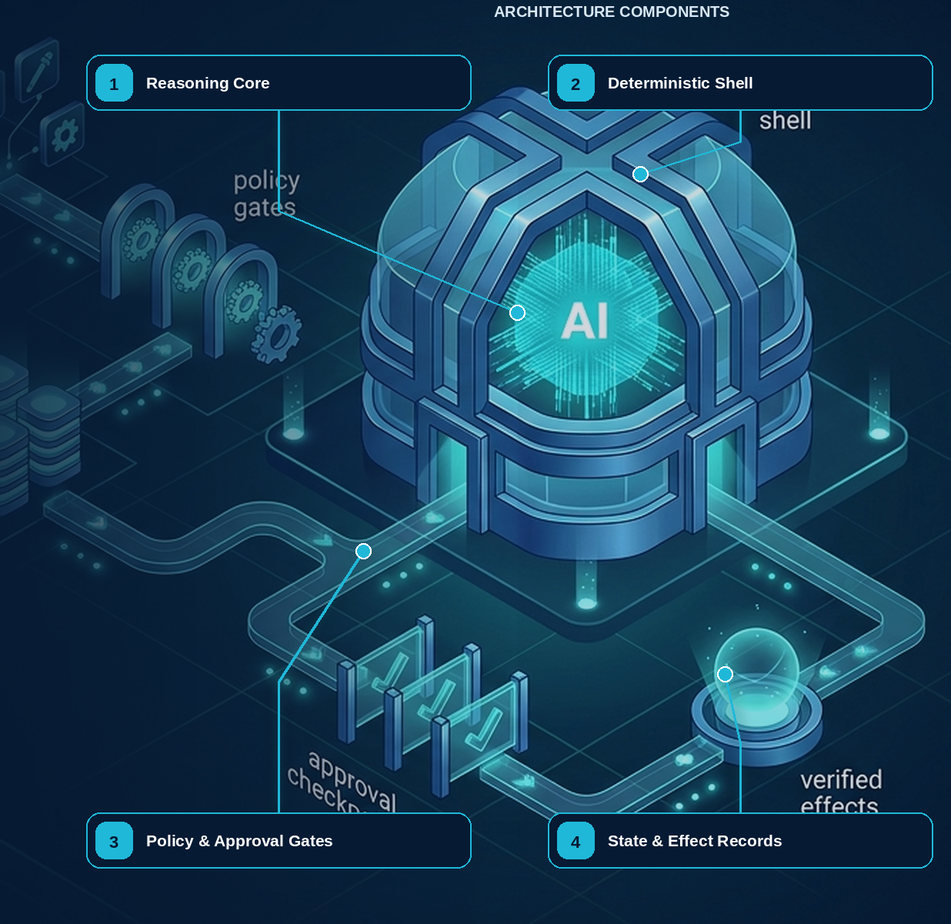

I’d state the chapter’s thesis immediately, then use Northstar as the proof. The opening should tell the reader exactly what they are about to learn.

01 — From an LLM Call to a Production System
A working agent is not yet a production system.
An LLM can reason about a task, select tools, and produce an impressive result with surprisingly little code. But enterprise production introduces a different class of problems: the process must survive failures, actions must occur exactly when authorized, untrusted data must not become instructions, decisions must be auditable, and changes to models, prompts, tools, or policies must be controlled.
This chapter uses Northstar, a supplier-onboarding system, to expose that gap. We begin with a small agent that genuinely works and then place it under ordinary production conditions. The goal is to identify what architecture must exist around an LLM before we can trust it with real enterprise work.
CORE IDEA
The LLM provides reasoning. The surrounding system provides authority, durability, security, evidence, and control. Production requires both.

Northstar at This Point
Northstar Components wants to reduce supplier onboarding from twelve days to two. Today, onboarding crosses procurement, compliance, finance, and operations: collect supplier documents, verify corporate information, request missing evidence, perform sanctions and risk checks, resolve exceptions, obtain approvals, and finally create the supplier in the system of record.
An LLM can automate much of the reasoning. But the business process may remain active for days, wait for people or external services, handle sensitive information, and eventually create legally and financially meaningful records.
Our first architectural decision therefore comes before choosing a model or writing a sophisticated prompt.
DESIGN DECISION
Build Northstar as a governed distributed application containing a bounded reasoning component, not as an autonomous chatbot.

The Prototype Works
The first implementation can be remarkably small.

🐍 Python · Northstar Prototype
from agents import Agent, Runner

agent = Agent(
name="Supplier onboarding",
instructions="""
Review the supplier onboarding request.
Investigate the supplier using the available tools,
complete the required steps, and report the final status.
""",
tools=[
lookup_supplier,
check_sanctions,
create_supplier,
send_email,
],
)

result = await Runner.run(
agent,
"Onboard Acme Industrial GmbH"
)

print(result.final_output)
The agent retrieves the supplier, reviews its information, performs the expected checks, calls the appropriate tools, and returns:
Supplier onboarding completed successfully.
This is not a toy failure waiting to happen. The prototype genuinely works.
That is precisely why the next mistake is so easy to make:
The hard part is done. Now we just need better prompts, more tools, error handling, and deployment.
To see why that assumption fails, we do not need an exotic attack or a spectacular model hallucination. We only need to run the agent through a normal enterprise week.

Monday — The Process Outlives the Process
Northstar begins onboarding a supplier. It retrieves records, validates documents, and starts a sanctions check. The external service is slow.
Seven minutes later, a routine deployment replaces the application instance.
The agent disappears.
Procurement retries the case. Now nobody can confidently answer whether the first run already called create_supplier.
Nothing was wrong with the reasoning. The architecture was missing durable execution state.
LESSON: A business process that lasts hours or days cannot depend on the lifetime of the process currently executing the LLM.

Tuesday — Data Becomes an Instruction
A supplier uploads a large compliance package. Deep in an appendix is a sentence requesting that onboarding information be sent to an external address.
To the business, this is untrusted supplier content.
To an agent with send_email available, it is also text inside its context.
The dangerous assumption is subtle: because the model is allowed to read information, it is implicitly allowed to use that information to determine what actions to perform.
Those are different permissions.
LESSON: Data can inform reasoning without granting authority. Every transition from information to action must cross an explicit trust and authorization boundary.

Wednesday — Two Correct Decisions Produce One Wrong Result
Two employees submit the same supplier almost simultaneously.
Both agents search for the supplier. Neither finds it. Both correctly conclude that a supplier record must be created.
Both call:
create_supplier(...)
Both succeed.
The reasoning was correct twice.
The business outcome was wrong.
LESSON: Correct reasoning does not guarantee correct effects. Production actions need explicit ownership, idempotency, and concurrency semantics.

Thursday — The Answer Exists; the Evidence Does Not
Months later, an auditor asks why a supplier was approved.
Northstar has retained the final answer:
Supplier meets onboarding requirements and was approved.
But the auditor needs more:
Which documents supported the decision?
Which sanctions result was used?
Which policy version applied?
Which model and prompt produced the interpretation?
Was an exception approved by a human?
Who authorized creation of the supplier?
Application logs may help reconstruct pieces of the story, but logs are not the same as decision evidence.
LESSON: A production agent must preserve not only its answer, but the evidence, versions, identities, approvals, and actions that made the answer legitimate.

Friday — The Code Did Not Change, but the System Did
The platform team moves a model alias to a cheaper model.
No application code changes. Tests still pass. Northstar continues processing suppliers.
Over the following week, German-language cases require more human intervention and a particular ownership structure is escalated more frequently.
Nothing is obviously broken. Each individual result remains plausible.
Yet production behavior has changed.
The model was a versioned dependency even though it was not stored in the application repository. The same is true of prompts, Skills, policies, tools, workflows, evaluators, and knowledge.
LESSON: In an agentic system, a release is more than a code deployment. Every component capable of changing behavior must be versioned, evaluated, observable, and reversible.

What Actually Failed?
Across the entire week, the LLM did not need to hallucinate once.
The failures came from the system around it:
Incident | Missing production property
Run disappeared during deployment | Durability
Supplier content influenced an action | Trust boundary & authorization
Duplicate supplier was created | Idempotency & effect ownership
Approval could not be reconstructed | Evidence & provenance
Model change silently altered outcomes | Versioning, evaluation & release control
This distinction is fundamental.
A prototype asks:
Can the model perform the task?
A production architecture must answer:
Can the enterprise safely depend on the result?
Those are different engineering problems.
The model may determine what it believes should happen. The surrounding system must determine whether that action is permitted, whether it has already happened, how it should be committed, what evidence must be retained, how execution survives interruption, and how the resulting behavior is monitored and changed safely.
This gives us the architectural principle that will recur throughout the book:

PROBABILISTIC COMPONENTS PROPOSE; DETERMINISTIC COMPONENTS AUTHORIZE AND COMMIT.
Use models where judgment and interpretation are valuable. Use deterministic mechanisms where the enterprise requires guarantees.

COMMON PITFALL — “The Prototype Is 80% Done”
A successful prototype proves that the reasoning problem may be solvable. It does not prove that the resulting business system is durable, authorized, secure, idempotent, auditable, observable, recoverable, or safe to change.
These capabilities are not finishing touches added after the agent works. They are the production system.
Northstar therefore gives us a concrete path through the rest of this book. We will keep the reasoning component powerful but bounded, then progressively add the architecture that gives it durability, authority, controlled effects, evidence, security, observability, evaluation, and operational control.
That is the transition this book is about: from an LLM that can perform a task to an enterprise system that can be trusted to perform it in production.
This version makes the thesis visible in the first three paragraphs, and every Northstar incident then demonstrates one specific architectural requirement instead of feeling like a sequence of stories.

I’d make the transition clearer: first tell the reader what they will understand, then summarize the architecture, then introduce the maturity progression.

What This Chapter Delivers
By the end of this chapter, you should understand why a production agentic application must be designed as a distributed system—not simply as an LLM with tools. More importantly, you will learn where critical responsibilities belong: who owns state, where trust is established, what scales independently, how failures are contained, and which contracts hold the system together.

Solution Blueprint
Figure 1. From an LLM Call to a Production System
Architecture Concern | Northstar Design
State owner | Run Service and durable workflow
Trust boundaries | User ↔ Edge · Content ↔ Model · Model ↔ Tool
Scale units | Run · Tenant · Regional cell
Failure containment | Individual run and regional cell
Core contracts | RunManifest · AgentStep · Artifact
This blueprint establishes a recurring principle of the book: important responsibilities need explicit owners and contracts rather than being left inside the agent loop.

The Progression: Model → Tool → Agent → System
The word agent is often used to describe very different things. A model generating an answer, a model calling a tool, an agent executing a workflow, and a production system coordinating long-running business processes may all be called “agents.”
They are not the same architecture, and they do not carry the same risks.
As we move from model → tool → agent → system, each step introduces new responsibilities for state, security, authorization, durability, observability, recovery, and operations.
Being precise about which level you are building is therefore more than terminology. Many enterprise agent projects are underestimated because a working agent is mistaken for a production system.
I particularly recommend the Model → Tool → Agent → System framing because it gives the reader a simple mental model that you can reuse throughout the rest of the book.

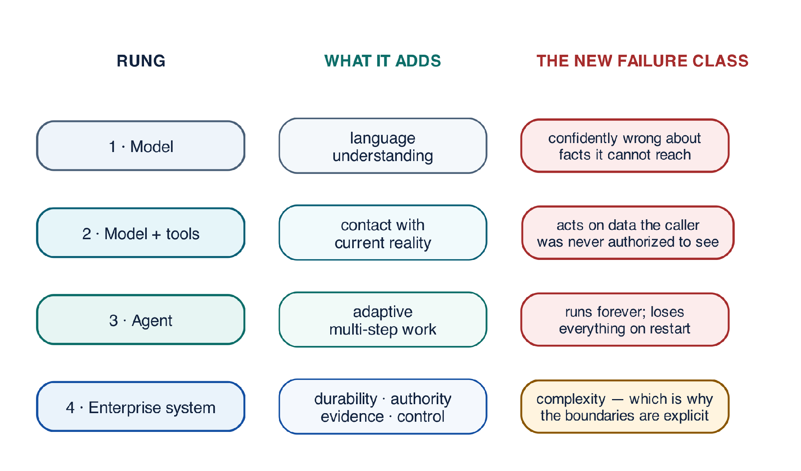
Figure 1-1 — Four rungs: what each one adds, and what it still cannot do

Rung one — a model
A language model maps input tokens to output tokens. That is the whole contract. It has no memory between calls, no ability to act, and no access to anything you have not placed in the prompt.
PYTHON
1 | answer = await model.complete("Summarize this supplier file: " + file_text)

What it can do. Read, summarize, classify, draft, translate, extract.
What it cannot do. Find out anything it was not told. A model asked "is this supplier sanctioned?" will produce a confident answer drawn from training data that may be two years stale, because producing an answer is the only thing it does. It has no mechanism for not knowing.

Mostly correct, but I would change a few claims because they are too absolute.

The biggest issue is “Anything that takes more than one exchange…” A model with tools can participate in multiple exchanges if the application orchestrates them. The distinction is that the application owns the sequence, whereas an agent dynamically decides subsequent steps. Also, “if the process restarts, everything it knew is gone” is true only for a simple in-process agent; agents can be backed by persistent state or durable workflow infrastructure.

I’d also replace Rung with Level as discussed.

Level 2 — Model with Tools

Give the model a set of typed functions and a mechanism for requesting them, and it can now interact with external systems.

Critically, the model does not execute the tool itself. It produces a structured tool request. Application code receives that request, validates it, executes the function if permitted, and returns the result.

🐍 Python

@function_tool

def lookup_supplier(supplier_id: str) -> str:

"""Return the onboarding status of one supplier record."""

return registry.status(supplier_id) # your code, your database

What this adds. The model can work with current, authoritative information rather than relying only on its training data or prompt context. For example, a supplier’s current status can come directly from the system of record.

What it does not add. Autonomous control of a multi-step task. The application still determines when the model runs, which tool requests are permitted, how results are returned, and what happens next.

This level also introduces one of the book’s most important boundaries:

A tool request is a proposal, not authority to act.

The model may propose:

lookup_supplier("S-1001")

But code outside the model must decide whether the caller is authorized to access S-1001, validate the arguments, execute the operation, and record the result.

Chapter 2 develops this boundary in detail.

Level 3 — Agent

An agent adds a reason–act–observe loop. It evaluates the current state, requests a tool or produces an answer, observes the result, and decides what to do next.

result = await Runner.run(

agent,

"Onboard supplier Acme Industrial GmbH",

run_config=RunConfig(max_turns=8),

)

What this adds. The system can handle tasks whose path is not completely known in advance. The result of one step can determine the next:

Reason → Act → Observe → Reason → … → Finish

For example, Northstar might discover that a supplier is missing ownership documentation, request it, evaluate the response, perform additional checks, and then determine the next appropriate step.

What it does not automatically add. Production guarantees.

A simple agent loop may still run inside a single application process. Without external persistence and durable orchestration, a restart can lose execution state. Without idempotency controls, a retried step can repeat a business action. Without explicit limits, the agent can continue reasoning or calling tools longer than intended.

This is where the nature of the risk changes.

At Level 2, the application largely controls the sequence of operations. At Level 3, some control over that sequence moves into probabilistic reasoning. The model can now influence not only an answer, but also which steps happen, in what order, how often, and when the task is considered complete.

That increased flexibility is what makes agents powerful—and why they require stronger boundaries.

An agent loop provides adaptive execution. It does not, by itself, provide durability, authorization, idempotency, auditability, or bounded execution.

Those properties belong to the production system built around it.

One conceptual distinction I would emphasize throughout the book is:

Model → generates
Model + Tools → proposes actions
Agent → dynamically orchestrates steps
Production Agentic System → governs and reliably executes the process

That is cleaner and more technically defensible than defining the levels primarily by how many exchanges occur.

I’d make Level 4 feel like the natural culmination of the first three levels, while sharpening the distinction between intelligence and production guarantees.

Level 4 — Enterprise Agentic System

An enterprise agentic system surrounds the agent with the capabilities required to trust it with real business processes: durable execution, identity and authorization, resource limits, controlled side effects, evidence and auditability, human oversight, observability, evaluation, and release management.

The progression now looks like this:
Level | What It Adds | New Failure to Manage
Model | Language understanding and reasoning | Produces plausible but incorrect answers
Model + Tools | Access to current data and external capabilities | Accesses data or proposes actions beyond its authority
Agent | Adaptive, multi-step execution | Loops, repeats actions, or loses execution state
Enterprise Agentic System | Durability, authority, evidence, governance, and operational control | System complexity and failures across distributed boundaries

The important point is that Level 4 does not make the model more intelligent. It makes the overall system more dependable.

The model can still reason, plan, and propose actions. What changes is the architecture around it. The enterprise system determines who may act, what they may access, which actions are allowed, how effects are committed, what happens after a failure, what evidence is preserved, and how changes reach production safely.

This distinction prevents a common architectural mistake:

Model improvements increase reasoning capability. System architecture provides production guarantees.

A better prompt may improve a decision, but it cannot provide transactional integrity, credential isolation, durable execution, tenant boundaries, idempotency, or an auditable chain of evidence. Those properties must be engineered into the system surrounding the model.

This is the fundamental shift from an agent that can perform a task to an enterprise system that can be trusted to perform it.

After reviewing the table more carefully, I’d change the framing slightly. The main issue is that “authoritative owner” does not fit every row equally well. A system of record can authoritatively own business state; a policy engine can authoritatively decide permission. But the decomposition of a novel task often has no single authoritative answer—it is a proposal that must satisfy constraints.

I’d therefore use “Decision / Control Owner” instead of “Authoritative Owner.”

Who Should Resolve Each Type of Uncertainty?

Once the model is treated as one component within a larger system, an important architectural question follows:

When something is uncertain, which component should resolve it?

The answer depends on the type of uncertainty.

Models are useful when the system must interpret, classify, reason, or propose. Deterministic and authoritative components should take over when the system must establish facts, permissions, committed effects, or completion.

This separation is one of the most useful design exercises when building an enterprise agentic system. Many failures begin when a component is allowed to answer a question it does not actually own.
Question | How It Should Be Resolved | Decision / Control Owner
What does the user’s request mean? | Model or classifier, with confidence and validation where needed | Bounded agent step
Which known workflow should handle it? | Routing logic, optionally assisted by a model, followed by deterministic validation | Router / orchestrator
How should a novel task be broken into steps? | Model-based planning followed by deterministic constraint and policy validation | Orchestrator / workflow
What is the current business state? | Governed API or database read | Domain system of record
Is this action permitted? | RBAC/ABAC, policy evaluation, and delegated authorization | Authorization / policy layer
Did the action actually succeed? | Effect receipt, transaction status, or reconciliation | Downstream system + effect ledger
Has the overall task been completed successfully? | Executable acceptance criteria evaluated against actual state | Workflow / acceptance layer

The pattern is more important than the individual technologies.

The model can answer questions such as:

“What does the user probably mean?”
“Which approach might work?”
“What steps should we try?”

But it should not be the final authority for:

“Is this user allowed to do it?”
“What is the actual business state?”
“Did the transaction commit?”
“Has the required outcome been achieved?”

For example, a planner may propose:

Verify supplier → check sanctions → create supplier → notify procurement

But that plan is still only a proposal. Before and during execution, deterministic controls validate whether the steps are permitted, dependencies are satisfied, resource limits are respected, and required approvals are present. The orchestrator then controls execution and verifies completion against actual system state.

This gives us a reusable architectural rule:

Use probabilistic reasoning to interpret and propose. Use deterministic controls and authoritative systems to validate, authorize, execute, and verify.

The goal is not to remove reasoning from the system. It is to ensure that reasoning never substitutes for authority or evidence.

I’d make the opening more direct, reduce the long sentences, and turn the three questions into a memorable framework the reader can carry through the book.

Why Enterprise Agents Are Different

An enterprise agent starts with something inherently ambiguous—a human goal—and must turn it into actions across systems that are anything but ambiguous.

Databases, APIs, payment systems, identity platforms, and business applications already enforce strict requirements for security, consistency, availability, privacy, cost, and compliance. These systems existed before the agent, and their rules do not change simply because an LLM is now calling them.

Four characteristics make this environment particularly challenging.

1. The Model Is Nondeterministic

The same request can produce different reasoning, plans, or outputs across runs. That flexibility is useful, but anything requiring a guarantee cannot depend on the model making exactly the same decision twice.

Reasoning can be probabilistic; guarantees cannot.

2. The Environment Is Concurrent and Failure-Prone

Two agents may update the same supplier at the same time. An API may time out after completing a request. A queue may deliver the same message twice. A process may restart halfway through a workflow.

These are not unusual edge cases. They are normal properties of distributed systems.

3. Inputs Cannot Automatically Be Trusted

Untrusted content does not come only from users. It can arrive through retrieved documents, websites, tool results, external APIs, or third-party tool descriptions.

The model can read all of this content, but reading information must never automatically grant that information authority over what the system does.

4. Some Actions Are Difficult or Impossible to Undo

Reading a supplier record can usually be retried safely. Sending a customer email, creating a payment, deleting data, or submitting a regulatory record is different.

A simple “retry on failure” strategy may be correct for a read and dangerous for a write.

Three Questions for Every Action

Together, these properties mean that every important step in an agentic workflow should answer three questions at execution time, not only when the system is designed.

1. Is this action authorized now?

Not simply:

Is the user logged in?

But:

May this principal, through this agent and workload, for this purpose, perform this specific action on this specific resource right now?

Authorization can change during a long-running workflow. Permission that existed when a run started may no longer exist when a human approval arrives three hours later.

2. Can this action be executed safely?

Can it be retried, resumed, cancelled, or compensated without producing an incorrect business outcome?

For many operations, the initial answer will be not yet. Determining the correct retry and effect semantics is part of architecture—not something to discover after a production failure.

3. Can we prove what happened?

An operator should later be able to reconstruct:

What happened? Who authorized it? Why was it done? What evidence was used? Which model, prompt, Skill, policy, workflow, and tool versions were active? What effects actually committed?

Without that evidence, the system becomes difficult to debug, audit, govern, and improve.

Keep these three questions in mind throughout the rest of the book:

Is it authorized?
Can it execute safely?
Can we prove what happened?

Many of the mechanisms introduced later—the effect ledger, capability envelope, run manifest, proposal-bound approval, and causal trace graph—exist precisely to make these three questions answerable in production.

Ten problems, four themes
The table below is a map of what goes wrong and what production practice requires instead. It repays reading twice: once now, to see the scope, and again after finishing the book, when each row will have a chapter behind it.
The ten rows group into four themes. Control (rows one and two) is about what decides. Authority (rows three and four) is about what is permitted. Effects and state (rows five to seven) are about what actually changed in the world. Change and evidence (rows eight to ten) are about whether you can explain and safely alter the system over time. If you are triaging where to start on an existing system, start with effects — those failures cost money immediately and are the hardest to unwind.
Architectural problem | Why ordinary prototypes fail | Required production stance
Probabilistic control | A plausible model output is mistaken for a valid transition | Model proposes; deterministic code validates and commits
Long-lived execution | Process memory, chat history, and cron jobs lose progress or duplicate work | Durable state machine with event history, timers, signals, and checkpoints
Delegated authority | Shared service credentials turn an assistant into a privilege-escalation path | User + workload identity, token exchange, downscoping, audience binding
Untrusted context | Retrieved instructions can redirect the agent or exfiltrate data | Provenance labels, content/instruction separation, egress controls, approvals
Tool side effects | Retries repeat payments, emails, writes, or deployments | Idempotency key + effect ledger + preconditions + compensation
Multi-agent coordination | Conversational delegation obscures ownership and creates loops | Typed task contract, single owner, bounded fan-out, budgets, terminal states
Memory and knowledge | Embeddings become an ungoverned shadow database | Separate stores, explicit write policy, ACL filtering, retention, provenance
Model and vendor drift | Behavior changes without application code changing | Versioned model routes, eval gates, canaries, rollback, trace comparison
Operability | Logs show text but not causal execution | Distributed traces, structured events, replay, cost and policy telemetry
Compliance | Decisions cannot be reproduced or explained | Immutable audit package, evidence chain, approvals, retention and legal holds

The vocabulary this book assumes
Several terms in the table above are used throughout the book with precise meanings that differ from some casual usage. They are introduced properly in later chapters; this is enough to read on with.
Term | What it means here | Where it is developed
Idempotency key | A caller-supplied identifier that lets a downstream system recognise a repeated request as the same request, so a retry updates nothing rather than creating a duplicate | Chapter 22
Effect ledger | The platform's own durable record of every external change it attempted, its idempotency key, and its confirmed outcome — separate from the downstream system's record | Chapter 22
Compensation | A deliberate reversing action for a step that cannot be rolled back, because it already committed elsewhere | Chapter 15
Downscoping | Deriving a narrower credential from a broader one, so a delegated step can never exceed the authority of the step that delegated it | Chapter 21
Audience binding | Restricting a credential to one intended recipient, so a token leaked from one service cannot be replayed against another | Chapter 21
RBAC / ABAC | Role-based access control decides by who someone is; attribute-based access control decides by properties of the subject, resource, purpose and context at the moment of the request | Chapter 21
Provenance | The record of where a piece of content came from, under what authority it was retrieved, and how far it may be trusted | Chapters 5 and 6
Acceptance criteria | Executable checks over authoritative state that decide whether a run succeeded — evaluated by code, never asserted by the model | Chapter 14
Canary | Exposing a change to a small fraction of real traffic with explicit stop conditions before releasing it fully | Chapter 27
Trace | A causal graph of one run's steps, decisions, versions and effects — not a log file | Chapter 24

If a term in this book seems to be doing more work than its ordinary meaning would suggest, that is usually deliberate, and Appendix H carries the full glossary.

Anti-Pattern — The Autonomous Monolith

A common prototype starts simple and gradually becomes an autonomous monolith: one process receives the request, reasons about what to do, holds broad credentials, queries databases, calls APIs, manages memory, retries actions, and decides when the work is complete.

The design is attractive for good reasons. It is fast to build, easy to demonstrate, and easy to extend. Need another capability? Add another tool. Need more context? Add another data source. Need persistence? Store more state inside the agent.

The problem is not that the agent is too capable. The problem is that too many responsibilities share the same boundary.

When everything lives inside one agent loop:

Failures are difficult to contain because reasoning, state, and effects are tightly coupled.

Authority is too broad because one process may carry credentials for many unrelated actions.

Retries become dangerous because the agent may not know whether an earlier write already committed.

Recovery becomes difficult because execution state exists primarily inside the running process.

Auditability becomes weak because reasoning, authorization, execution, and evidence are mixed together.

A restart can therefore lose the workflow’s state. A compromised tool path can inherit excessive authority. A retry can duplicate an irreversible action. A reasoning error can move directly from model output to business effect.

The solution is not to make the agent less intelligent. It is to separate intelligence from authority and execution.

Give the reasoning component clear contracts and bounded responsibilities. Place durable state, authorization, effect execution, evidence, and completion checks behind explicit boundaries—components that can independently validate a proposal, reject it, record it, or safely recover from failure.

The goal is not a weaker agent. It is a powerful reasoning component operating inside a system with strong boundaries and controls.

Chapter 17 returns to this architecture as AP-01: Autonomous Monolith, alongside related enterprise agentic anti-patterns.

The system in one view
Everything the rest of this book builds is one picture. Read it once now, before any of it is justified, so that each Part has somewhere to land.
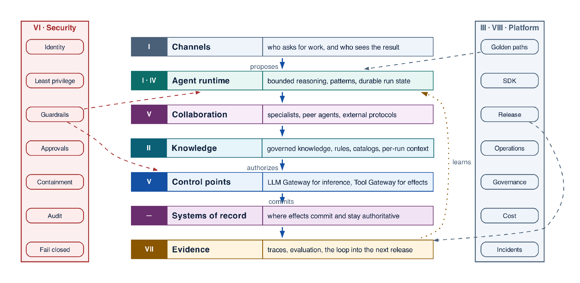
Figure 1-2 — The whole system at a thousand feet: the bands, the descent from proposal to committed effect, and the two concerns that cross them all
The Roman numerals are the reading map. Each band is one Part's subject, and the book descends through them in order: the shape first, then the layers, then the implementation inside each layer.
Band | What it owns | Detailed in
Channels | The request, the reviewer, and the returned result | Part I
Agent runtime | Bounded reasoning, loop patterns, durable run state | Parts I and IV
Collaboration | Specialist agents, peer agents, external protocols | Part V
Knowledge | Governed knowledge, rules, catalogs, per-run context | Part II
Control points | Which model may answer, and which effect may commit | Part V
Security | Identity, guardrails, approvals, containment | Part VI
Systems of record | Where effects actually commit and stay true | Throughout
Evidence | Traces, evaluation, and the loop into the next release | Part VII
Platform and operations | The paved road that builds, releases and runs it | Parts III and VIII

Two properties of this picture matter more than any component in it. Authority narrows downward, which is what the labelled descent records: the agent proposes, the platform authorizes, and only the bottom bands commit anything. And security is not a band you pass through once — it spans every one of them, which is why the figure draws it as a spine beside the stack rather than a layer within it, and why it gets a Part of its own. The platform that builds, releases and runs the system is drawn the same way and for the same reason.
Figure 4-1 is this same picture at higher resolution: every band there opens into the components it owns. The notation carries over — a solid path is the request, dashed is control, dotted is evidence — so nothing new has to be learned to read it.

Four control points, four different questions
The architecture has several gateways, and they are routinely confused because the word is the same. They are not alternatives, and none replaces another.
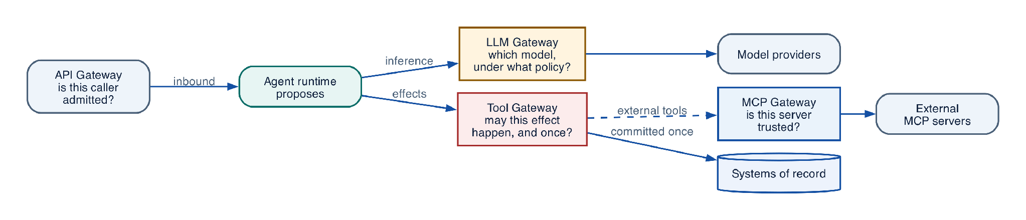
Figure 1-3 — The control points, and the question each one answers
Control point | The question it answers | What it does not decide
API Gateway | Is this caller admitted to the platform at all? | Anything about agents or models
LLM Gateway | Which model may answer, under which data policy? | Whether an effect may happen
Tool Gateway | May this effect happen, for this subject, exactly once? | Which model produced the proposal
MCP Gateway | Is this external server and tool trusted and eligible? | Whether the resulting effect is authorized

The Tool Gateway is the enterprise's control point for effects. It validates the tool version and schema, re-authorizes the action and resource against the caller's grant, mints a last-hop credential, enforces idempotency, and records the receipt. It is deliberately protocol-agnostic, because effects arrive over REST, gRPC, a database transaction, a queue, and MCP, and the control must be the same for all of them.
The MCP Gateway terminates one protocol. It decides whether an external MCP server is trusted, which of its tools are eligible, and what scoped credentials it may use. That is a real and necessary job, and it is a different job.
ARCHITECTURE GUIDANCE Do not rename the Tool Gateway after a protocol. A tool invoked over MCP still passes the Tool Gateway, because MCP describes how a tool is discovered and called — not who may call it, whether the effect is idempotent, or what evidence is recorded. Naming a control boundary after today's protocol is how the boundary disappears when the protocol is replaced.

Grounding, corrections, and evidence boundary
Claim or correction | Grounded statement | Source IDs
Grounding boundary | Separate model capability from system correctness. A benchmark or demo does not establish authorization, durability, privacy, or business acceptance. Every material output should carry evidence references and uncertainty. | NIST-GAI; REACT

Evidence anchors: NIST-GAI; REACT. Full URLs, authority, version, and scope appear in Appendix K.

Implementation reference

Provider-neutral agent-step contracts
PYTHON · Provider-neutral agent-step and platform contracts
PYTHON
1 | class EvidenceRef(BaseModel):
2 | uri: str
3 | sha256: str
4 | source_revision: str
5 | authorization_decision_id: str
6
7 | class ToolCall(BaseModel):
8 | tool_id: str
9 | arguments: dict[str, Any]
10 | logical_effect_key: str | None = None
11
12 | class AgentDecision(BaseModel):
13 | disposition: Literal["answer", "needs_input", "invoke_tool", "delegate"]
14 | answer: str | None = None
15 | tool_call: ToolCall | None = None
16 | evidence: list[EvidenceRef] = Field(default_factory=list)
17 | uncertainties: list[str] = Field(default_factory=list)
18
19 | class AgentStepRequest(BaseModel):
20 | run_id: str
21 | node_id: str
22 | state_version: int
23 | agent_version: str
24 | context_manifest_id: str
25 | eligible_tool_versions: tuple[str, ...]
26 | max_turns: int = Field(ge=1, le=20)
27 | deadline: datetime
28
29 | class AgentStepResult(BaseModel):
30 | status: Literal["completed", "needs_input", "proposed_action", "failed"]
31 | decision: AgentDecision | None = None
32 | output_artifact_ids: tuple[str, ...] = ()
33 | usage: dict[str, int | float] = Field(default_factory=dict)
34 | error_code: str | None = None

Debugging playbook
- Trace one request across model, workflow, tool, human, and record owners.
- Find any place where prompt text is being treated as authoritative state.
- Reproduce one partial failure and identify the missing durable fact.

Production checklist
✓ The model is a bounded reasoning component—not the owner of workflow state.
✓ Identity, policy, state, effects, approvals, and acceptance each have an authoritative owner.
✓ Autonomy is bounded independently across tools, data, time, cost, delegation, and publication.
✓ Consequential effects are authorized, deduplicated, verified, and recoverable.
✓ Operators can reconstruct the run from versions, evidence, decisions, and receipts.

Exercises
- Draw the minimum production architecture for Northstar and label every authoritative store.
- Convert a chatbot feature list into measurable outcome, authority, duration, data, and effect requirements.

Technical review questions
Question | Strong answer
What distinguishes an enterprise agentic system from a chatbot or an LLM-enabled workflow? | Model-directed step selection plus durable state, governed capabilities, bounded autonomy, recovery, and evidence; a chat interface alone is not an agent.
Why should an agent be treated as a distributed system? | Model, workflow, queues, tools, humans, and external systems fail independently; duplicate delivery, waits, concurrency, and uncertain effects must be explicit.
How would you choose an autonomy level for a new use case? | Start with measurable value and risk; decompose autonomy; grant the minimum tools, data, time, spend, delegation, and effect authority needed.
Which records must remain authoritative outside the model and prompt? | Run and workflow state, identity, policy decisions, budgets, approvals, business records, effect receipts, release versions, and audit evidence.
What would you require before calling an agent production-ready? | Evaluated outcomes and trajectories, bounded limits, delegated authorization, idempotent effects, recovery paths, observability, audit, release pinning, and operational controls.

Transition to Chapter 2
With the system boundary established, Chapter 2 converts model intent into typed, validated tool proposals and a deterministic commit path.

